Hybrid Scales in Cryogenic Applications

Cryogenics
Liquid Nitrogen (LN₂) is nitrogen gas which is in a liquid state at a temperature of -195.76 °F. The gas is turned to liquid for ease of transport. This material boils immediately upon contact with a warmer object and causes the nitrogen gas to release and fog and surround the object of which it was in contact. LN₂ is used in a wide variety of applications such as cryogenic therapies, fire prevention systems, biological sample preservation, shrink-welding, and a super coolant for high-temperature conductors.

LN₂ effects on scales
When Liquide Nitrogen Gas or any other sub temperature gases are loaded into vessels, the material on which the vessel rest is very important as the LN₂ can have an adverse effect on the substrate materials. If the vessel is sitting on a scale with a mild steel or concrete deck, for instance, this can be very problematic for the longevity of the scale. If the LN₂ is spilled or vented onto the scale it will cause the scale deck to instantly freeze which causes the gases to release and fog up the surrounding area. This instant freeze situation is detrimental to a mild steel or concrete deck scale as it causes them to instantly contract. In addition to the spillage, the tankers will sometimes vent off the bottom of the tanks and create blow down onto the scale deck. This blow down hits the deck of the scale and migrates down the length of the deck, thus exposing the deck surface to these extreme sub-zero temperatures. In the cases of a mild steel deck scale, this exposure leads to embrittlement of the steel and possible structural failure. In the event this spill takes place on a concrete deck scale this drastic freezing situation will cause the concrete to immediately crack and cause spalling in the deck of the scale. This spall effect leaves voids behind that after each spillage event continue to get worse until the concrete deck is no longer useable for the customer. In both scale examples the life expectancy of the scale is greatly reduced as the structures are compromised each time a spill or vent down event occurs. This is where stainless steel deck plate comes into play as it is more forgiving when exposed to such an extreme low temperature.

Fairbanks offering
Through years of experience Fairbanks Scales has found that a Hybrid scale solution is best for the customer that is filling vessels on the scales or actively releases the “blow-down” venting. Our solution is to provide the entire module the filling application is on with a mild steel sub-structure and a stainless steel deck plate. This provides the protection typically needed to increase the longevity of the scale and prevent the decks from cracking. Historically, customers have asked for a 5 foot or even 17 foot blow down protection area to be of stainless steel based on the placement of the trucks. This makes sense on the surface, but through years of experience and trials with this method we have found that this is not a good fit for most applications because the gas will typically migrate down the scale deck and cause cracks further away than the blow down vent. For example: if a blow down vent is 17’ from the end of the scale the gas migration can go as far as an additional 35’ from the end of the scale with subzero temperatures. For these applications we use complete stainless steel deck module placed under the truck blowdown area, while the remainder of the scale is a standard mild steel deck. This combination of mild and stainless steel deck modules (or concrete) is what we refer to as a Hybrid scale. We can apply this approach to Trident, Talon, and Titan modular scales.

Please reference the examples below of Fairbanks Scales currently installed.

In this example the blow down vent is 17’ from the end of scale on a Titan truck scale application. The entire 35’ module has a stainless steel deck.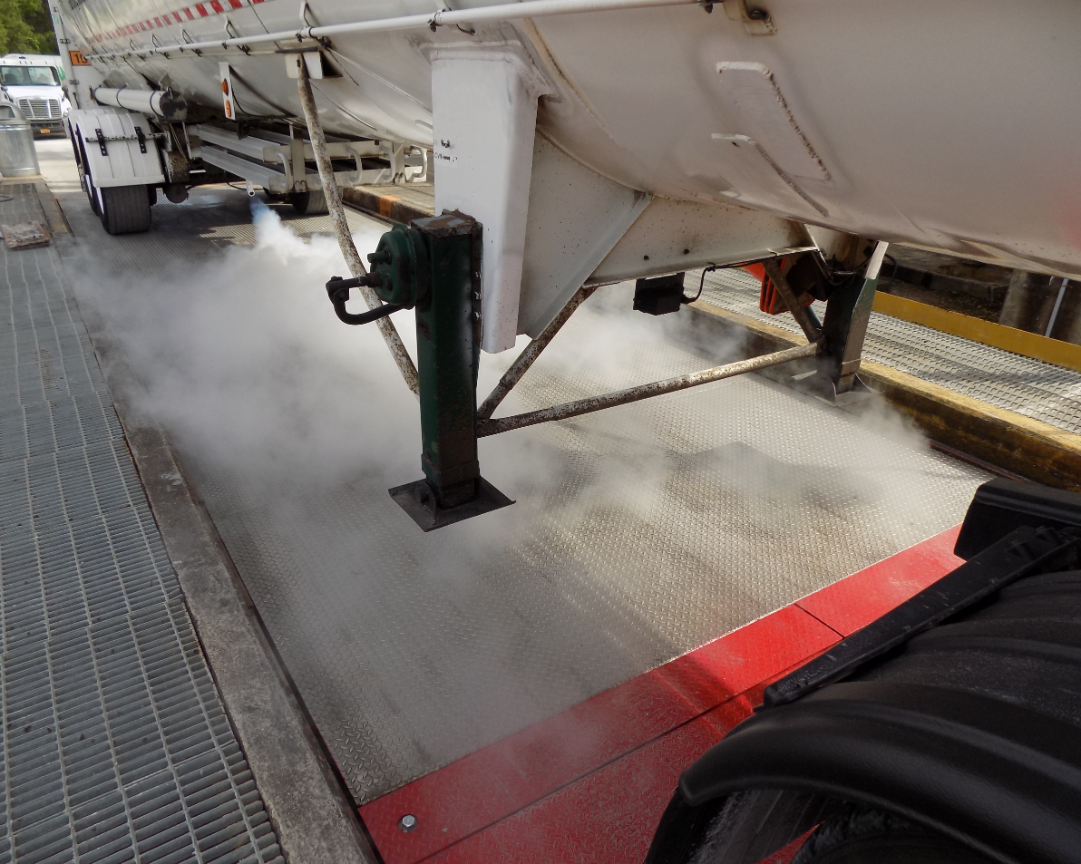 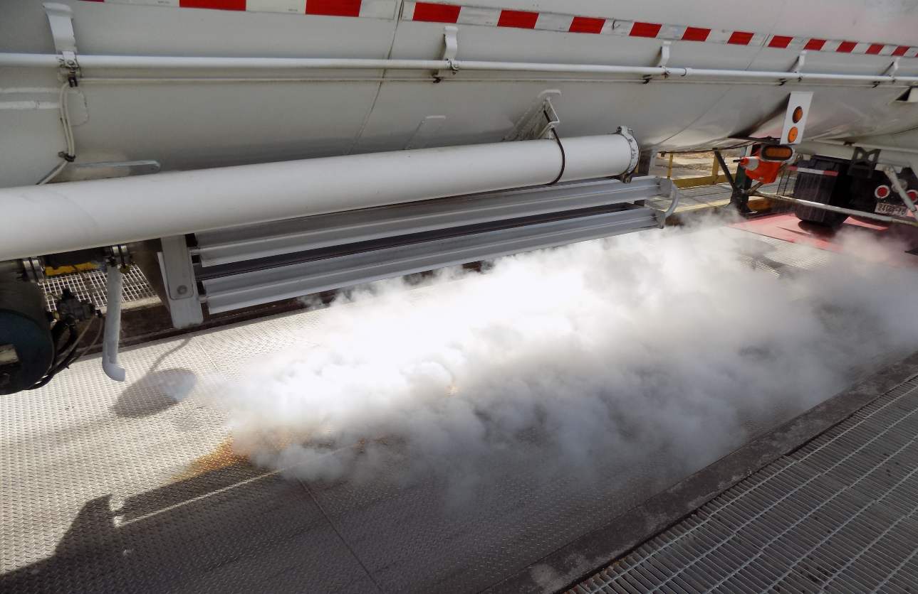
Stainless Steel Deck
Mild Steel Deck

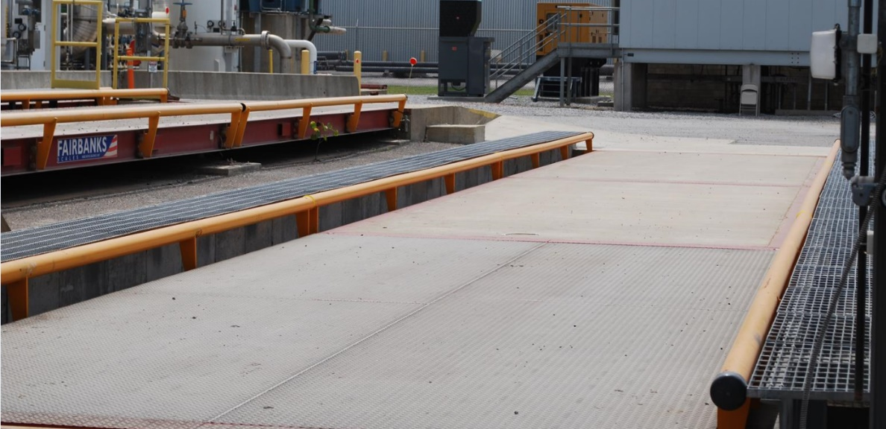
In this example we have a pair of Talon Hybrid Field Pour scales with a 23’ stainless steel deck module
Stainless Steel Deck
Concrete Deck

